Code of Practice for the Management of Dogs and Cats in Shelters and Pounds (revision 1).

Table of Contents

Headings | Page Number
Introduction
Definitions
Staff
The proprietor
The veterinarian
Animal attendants
Staff health
Handling and Treatment
Capture
Admission
Vaccination
Quarantine
Isolation
Euthanasia
Maintenance Procedures
Nutrition
Disinfection and hygiene
Inspection
Exercise and grooming
Re-homing and Foster Care
Public Access to Establishments
Release of Animals to Research Institutions
Establishment Buildings and Housing Facilities
Food storage and hygiene
Housing facilities
Pens, cages and modules
Examination, treatment and euthanasia facilities
Pen sizes
Holding facilities
Records

Introduction

This Code of Practice is made under the provisions of Section 59 of Division 4 of the Domestic (Feral and Nuisance) Animals Act 1994.
The purpose of the Code of Practice is to specify the minimum standards of accommodation, management and care, which are appropriate to the physical and behavioural needs of dogs and cats housed in establishments.
The Code of Practice and its provisions are to be observed by the proprietor and manager of establishment and by people who work in them. All establishments must comply with State and Local Government legislation and permits.
The Code of Practice is designed to cover all animal welfare shelters and Council pounds, and includes any holding facilities used by these establishments. Holding facilities for the short term housing of animals prior to transportation to an establishment must comply with this Code of Practice. This Code of Practice primarily addresses the short term housing requirements of animals in pounds and shelters; however specific reference conditions apply to the long term housing of animals seized and held for periods greater than 36 days.
This Code of Practice does not apply to wildlife shelters operated by persons holding an authorisation under Section 24A of the Wildlife Act 1975 to establish a shelter for the rehabilitation of native wildlife.
All establishments must carry a minimum of $10,000,000 Public Liability insurance cover.

Definitions (solely for the purpose of interpreting this Code of Practice)

“Act” means the Domestic (Feral and Nuisance) Animals Act 1994;
“Animal” means dog, puppy, cat and kitten;
“Bank of Cages” means a multi level structure designed to house a cat or kitten;
“Bed” means an impervious structure, raised off the level of the floor, that is large enough to cater for the size of the animal housed in the pen, cage or module;
“Cage” means a structure designed to house a cat or kitten;
“Cat” means any animal identified as Felis catus aged 12 weeks or older;
“Colony Pen” means a walk in structure designed to house up to eight cats or kittens;
“Disinfection” means a product used on an inanimate surface to kill micro-organisms, thus sterilising them.
“Dog” means any animal identified as Canis familiaris aged 16 weeks or older;
“Establishment” means a welfare shelter or Council pound;
“Facility” means all animal areas; cages, holding facilities, isolation housing, pen, exercise area, procedure room and admittance room
“Holding facilities” means pens, cages or modules for housing animals for a term being less than 24 hours;
“Impervious” means materials or sealed materials that prevent water, urine or any other liquids penetrating the material or being absorbed and held by the material;
“Isolation housing” means pens, cages or modules, that are kept in a separate area and used for Animals suspected of having or diagnosed with an infectious disease;
“Kitten” means any animal identified as Felis catus aged less than 12 weeks;
“Manager” means a person responsible for the day to day operation of an establishment;
“Module” means a structure designed to house a cat or kitten after the quarantine period;
“On call” means contactable and available to attend an establishment promptly, at any time over a 24-hour period;
“Pen” means a structure designed to house a dog or puppy;
“Pound” means any premises maintained for the purpose of impounding dogs or cats;
“Proprietor” means the person who owns the shelter or pound, in the case of a Council Pound the Chief Executive Officer is considered to be the proprietor; In the case of a Shelter with a board of management the Executive Officer is considered the proprietor.
“Quarantine” separation from other animals until the vaccination becomes effective.
“Puppy” means any animal identified as Canis familiaris aged less than 16 weeks;
“Scanned” means pass a reader over the skin of an animal at a distance of no greater than 50mm and at a sweep speed of no greater than 50cm per second
“Shelter” means any premises maintained for the purpose of providing shelter to, or finding new homes for, stray, abandoned or unwanted dogs or cats;
“Seize” means an animal seized under part 2 or 7A of the DFNA Act
“Statutory period” means housing of animals for the eight days as per the Act;
“Surrender” means an animal relinquished by the owner
“Raised sleeping quarters” means a structure large enough to cater for the size of the animal, which is off the floor of the pen, cage or module;
“Re-homing” means to sell an animal;
“Transitional period” means the period between the “post statutory” and “quarantine period”
“Washable” means the surface allows for complete disinfection of an area;
“Weatherproof” means protection for the wind, rain, and extreme temperatures protecting the welfare of the animals housed in the establishment.

General
1. Staff
1.1 Proprietor

The proprietor of an establishment must have a written health management plan that has been formulated in consultation with and approved by a Veterinarian. The proprietor may act as or appoint an operations manager.

The Proprietor of an Establishment is responsible for:
- ensuring all requirements in this Code of Practice are met
- the overall management and conduct of the establishment
- the health and wellbeing of the animals within the establishment
- Promoting and supporting appropriate formal and informal training to staff
- ensuring there is a written and signed agreement stating who will be responsible for any building or plant work and where both parties’ responsibilities are clearly defined if the proprietor is leasing the premises
- having a written agreement with sufficient veterinarians to provide prompt treatment, first-aide and if necessary humane euthanasia
- preparing an animal health plan to be endorsed by a veterinarian

The Animal health plan must cover:
- response to outbreak of disease
- vaccination program
- approved euthanasia
- assessment programs for fostering animals
- management of isolation facilities
- environmental enrichment
- behavioural and welfare assessment of animals impounded longer than 36 days
- parasite prevention
- protocols for temperament and health assessment for re-homing animals

1.2 Operations Manager

An operations Manager must have completed a Certificate IV in Animal Care and Management; or have experience or qualifications of an equal or greater level.

The Manager will be responsible for:

- ensuring compliance with the relevant legislation and Codes of Practice
- the well-being of all animals in the establishment;
- Reporting to the proprietor on matters of compliance
- carrying out the directions of the veterinarian in the event of an outbreak of disease
- the supervision of staff;
- the maintenance and collation of records and statistics;
- supervision of daily feeding, watering and inspection of all animals;
- supervision and examination of animals upon entry;
- the overall level of hygiene in the establishment, including the disposal of waste materials;
- provision of prompt veterinary attention for animals when required; and
- developing and prominently displaying at the establishment a plan for an emergency situation for both humans and animals,

1.3 Animal Attendants

Animal attendants who work at the establishment must be trained and experienced to properly manage the type of animals held. The minimum equivalent of one full-time animal attendant must be employed for every 40 animals housed.
Animal attendants are responsible for reporting to the operation manager:
- daily feeding, watering and inspection of all animals;
- daily cleaning of facilities, i.e. hose out, replace bedding, litter trays, feeding and watering utensils;
- exercising and enrichment of animals as required; and
- reporting to the proprietor animals showing any of the following symptoms:
. runny nose
. runny or inflamed eyes
. repeated sneezing
. coughing
. vomiting
. diarrhoea, especially if bloodstained
. lameness
. inability to stand or walk
. bleeding or swelling of body parts
. weight loss
. inappetence
. apparent pain
. fits or staggering
. bloating of abdomen
. difficulty or inability to urinate or defecate
. red or brown coloured urine
. any other serious physical or behaviour abnormality.

1.4 The Veterinarian

A veterinarian should endorse the proprietor’s animal health plan.

The written agreement between the proprietor and the veterinarian must include:
- the use of the veterinarian’s facilities for the treatment of animals for first aid
- for the provision of isolation housing if the establishment does not have a separate first aid and treatment area or isolation housing.
Only animals housed for veterinary treatment at a veterinary clinic and under direct veterinary supervision can be housed in pens, cages or modules contrary to this Code of Practice.

Where directed by a veterinarian, unweaned, severely injured and diseased animals can be euthanased humanely.
1.5 The vehicle driver
An Authorised Officer of Council and/or the driver of an establishment’s animal transport vehicle must be an experienced and trained animal attendant, responsible for the following tasks:
- assessing the animals being transported against the categories in 2.2.1 and taking the appropriate action for the welfare of the animal;
- the care and welfare of all animals during transport, except where a veterinarian also travels in the vehicle with the animals;
- the hygiene and cleanliness of the vehicle including routine disinfection;
- When an animal shows signs of infectious disease or defecates, vomits or urinates in the cargo area drivers must disinfect the cargo area of the vehicle before another animal can be placed in the cargo area.
Animals must be transported for the minimum time practicable taking into consideration the most direct route from the area where the animal was collected back to the holding pen or establishment.
Cats and small dogs may be placed in secure baskets, cages or boxes, large dogs must be restrained and all Animals must be physically separated.
Where the pick-up of stray or injured animals is conducted on a shuttle basis the timetable must be based on ensuring minimum time in transit for distressed or injured animals.
Severely injured animals should be euthanased by an appropriately authorised officer or transported to the nearest point of veterinary attention as soon as possible.

1.6 Staff (and volunteer) health

Potential health risks for humans exist when working with animals. Some animals may harbour disease-causing organisms, which can be transmitted to humans (zoonoses). To protect staff health a list of common zoonoses associated with animals must be prominently displayed throughout the establishment and staff must be educated in zoonosis.

Staff health must be protected by the provision of:
- appropriate work clothing
- hot and cold hand washing facilities
- disinfectant soap and hand washing posters at the establishment
- adequate information and training on health and safety at the induction session
- Tetanus immunisation
Members of the public’s health must be protected by having access to hot and cold water hand washing facilities with disinfectant soap.
All personnel working with cats, especially women of childbearing age, must be made aware of the risk of contracting toxoplasmosis.

2. Handling and treatment of Animals
2.1 Capture
Capture methods must be as humane as possible with minimum risk to operators, bystanders and animals. The behaviour of the species and individual animal concerned must be taken into account when deciding on the methods used.
2.2 Handling and treatment
2.2.1 Admission
Every animal admitted to an establishment must be scanned and checked for identification and examined by a veterinarian, or by an experienced person, who is responsible for classifying animals into the following categories for attention:
a. Healthy animals
b. Moderately or slightly injured animals - to be given prompt first-aid to relieve pain and preserve life, and held for observation;
c. Severely injured animals, unidentified cats that are wild or uncontrollable or unweaned and orphaned animals - to be promptly and humanely euthanased.
d. Animals with infectious disease are to be held in isolation housing.
2.3.2 Vaccination

All dogs sold from an establishment must be vaccinated to cover the following diseases:
- Canine Distemper
- Infectious Canine Hepatitis
- Canine Parvovirus
- Canine Cough (Parainfluenza (Type II) and Bordetella bronchiseptica).

All cats sold from an establishment must be vaccinated to cover the following diseases;
- Infectious Feline Enteritis
- Feline Respiratory Disease (feline calicivirus and feline herpes virus)

2.3.3 Quarantine

Prior to animals being made available for re-homing all animals are to be vaccinated and serve an 8 day post vaccination quarantine period. The only exception is if the animal was previously vaccinated, presented with a current vaccination certificate and free from infectious disease.
At the end of the quarantine period, all animals must again be examined by the operational manager or a veterinarian to assess their suitability for sale.

2.3.4 Isolation
All establishments must include isolation housing, for animals with infectious diseases or have a written agreement with a veterinarian to provide isolation housing.
Isolation housing within the establishment must be physically separated by an impervious barrier or a distance of at least 10 metres from other animal accommodation at the establishment. Animals must be maintained in an area approved in the animal health management plan –with particular reference to the area’s airflow, workflow, cage or pen type, staff and goods flow.

All animals confined in isolation housing must be under veterinary supervision and the fate of an animal should be decided by the veterinarian.
2.3.5 Euthanasia
At the conclusion of the mandatory eight days statutory period specified in the Domestic (Feral and Nuisance) Animals Act 1994 for stray animals, animals may be euthanased because of disease, injury, behaviour, age, unsuitability for sale or in accordance with the Act.
The accepted method of humane euthanasia is barbiturate overdose, which must be carried out by a veterinarian.
Euthanasia must be performed in an area that is separated from animal accommodation at the establishment and must not be carried out in view of any other animals or members of the public.
Should a proprietor decide that a gunshot is the only practical method of euthanasia, shooting must only be performed by highly skilled experienced operators trained in the use of firearms and only in jurisdictions that allow legal firearm use. Personnel, public and nearby animal safety must be considered. This procedure must be performed away from the public and other animals.
Euthanasia methods must be carried out in accordance with the Prevention of Cruelty to Animals Act 1986. (Guidelines on humane methods of euthanasia can be sought from the AVMA 2007 guidelines on euthanasia)

2.3.6 Maintenance procedures
a. Nutrition

All dogs and cats must be fed a nutritionally balanced diet at least once a day. Puppies and kittens between three and four months of age must receive a minimum of three feeds a day and between four and six months of age must be fed a minimum of twice daily with a nutritionally balanced diet. The food provided must contain acceptable nutritive values in sufficient quantity to meet appropriate daily requirements for the condition and size of the animal.
All animals must have a continuous supply of fresh, clean water. The amount of water needed daily by an adult dog or cat is approximately 50 millilitres of water per 1 kilogram of body weight. The amount of water any dog or cat needs daily may vary depending on a number of factors including daily temperature, amount of exercise, lactation, water content of diet (i.e. greater water requirements if fed dry food compared to canned food), age etc.
Food and water containers must be non spillable and easily cleaned and disinfected and must not cause injury to the animals.
For dogs and weaned puppies, one feeding bowl must be provided per individual animal. For cats, there must be one feeding bowl per adult and one feeding bowl per three kittens (less than 12 weeks).
b. Disinfection and hygiene

An important management requirement is the maintenance of a hygienic establishment to prevent build-up of disease causing organisms including viruses and parasitic worm eggs. The establishment is to be clean and hygienic at all times. All pens, cages and modules must be cleaned out at least once per day (or more often as required) by hosing or other appropriate means. All faeces used bedding, used Cat litter and all uneaten food must be removed prior to hosing. Used litter and uneaten food must be placed in a waste disposal device.
Establishments must have an adequate water supply and must be sewered or on a septic system, or have some other adequate method of disposing of faeces.
Waste disposal must be in accordance with the requirements of the appropriate statutory authority. Use of a trade waste service for collection and disposal of wastes is preferable. Wastes must not be incinerated unless the incinerator is registered with the Environment Protection Authority.
After cleaning, sleeping areas must not be allowed to remain wet.
Cats must be provided with clean litter trays daily and litter trays must be disinfected regularly. Sufficient suitable litter material, such as commercial cat litter, sawdust or shredded paper, must be provided.
Disinfection of pens, cages, and modules must be done whenever the pen/cage is vacated or every eighth day with an animal disease specific disinfectant. Phenol must not be used for cats. Manufacturer’s instructions for the use of these agents must be followed.
All watering and feeding utensils must be cleaned daily. Utensils must be rinsed after disinfecting to avoid poisoning.
Pests including fleas, ticks, flies, mosquitoes and rodents must be effectively controlled. Chemicals used for pest control must be either prescribed by a registered veterinarian and\or registered by the Australian Pesticides and Veterinary Medicines Authority (APVMA) under the Agricultural and Veterinary Chemicals Code Act 1994 (Commonwealth) and used only in accordance with manufacturer’s instructions. Material Safety Data Sheets for all chemical used at the establishment must be current and kept on site in an accessible format.

c. Inspection
Animal attendants must inspect all dogs and cats housed at the establishment at least once each day to assess if any change in health or temperament is observed and noting the animals’ general appearance and behaviour. Puppies and kittens must be observed at least twice each day to assess if any change in health or temperament is observed and noting the animals’ general appearance and behaviour.
It is the responsibility of animal attendants at establishments to report any animal that appears sick or injured, or is behaving oddly, to the proprietor or veterinarian as soon as possible. Animals suspected of having an infectious disease must be placed in isolation for treatment by a veterinarian.

d. Enrichment
Environmental enrichment should be provided regularly to all animals– this could be in the form of exercise, forage opportunities, toys, play materials, grooming and socialisation. All enrichment and socialisation must be controlled to avoid risk of contamination of other animals. Items should be able to be disinfected or be disposable.
Where an animal enters the facility and is known likely to be held for an extended period for legal reasons the animal MUST be assessed individually, on entry and, at least, monthly, for their physical, psychological and social well being.
Animals held for long periods of time MUST have environmental enrichment daily; this must be assessed for safety to the handler and the animal and should be regularly varied

The type of enrichment for all animals could vary depending on the animal, the type of containment required for the animal and the period of confinement as per table below.

DOGS (puppies)
Quarantine period (8 days) | Post Quarantine period | Long term housed animals (greater than 36 days)
- If there is an exercise area, suitable for quarantine animals, the area and route to the area must be decontaminated afterwards.  - Exercise can occur in the animal’s own pen or cage by encouraging activity (such as tug of war, hiding food treats).  - Environmental enrichment should be provided – using equipment that can be disposed of, sterilised or decontaminated.  - Grooming is encouraged – using equipment allocated to only that animal and equipment that is disposable or can be sterilised or decontaminated.  - Human interaction should be encouraged but, human safety, hygiene and risk of contamination must be considered and addressed. | - Grooming is encouraged, grooming areas may be provided by a grooming service provided that the grooming is completed inside establishment’s premises and the establishment has a written agreement with the grooming service.  - Dogs (that are not seized) can be exercised outside the establishment. They must be accompanied by an experienced and trained animal attendant. No more than two dogs per animal attendant can be walked outside the establishment. The dog must be restrained by a chain, cord or leash at all times while outside the establishment. A proprietor should conduct a risk assessment to determine if offsite exercise is necessary and must develop a policy for walking dogs outside the establishment for public safety.  - For exercise and socialisation periods, up to 6 compatible dogs can be exercised in an area. Where enclosures are separated by physical barrier (i.e. different room) a staff member must be in visual and audible range of animals in each enclosure at all times.  - Exercise can occur in the animal’s own pen or cage by encouraging activity (such as ’fetch’, hiding treats)  - Human interaction should be encouraged but human safety, hygiene and risk of contamination must be considered and addressed. | - Time in a secure exercise area  - Exercise can occur in the animal’s area by encouraging activity (such as foraging)  - Environmental enrichment should be provided – using equipment that can be sterilised or decontaminated or disposed of (such as toys, shredded paper, boxes, chew toys)  - Human interaction should be encouraged but, human safety, hygiene and risk of contamination must be considered and addressed.  - Grooming is encouraged – using equipment that is disposable or can be sterilised or decontaminated

Exercise/socialisation areas (dogs):

If the exercise area is outside it must not be muddy, bare or dusty. Care must be taken to ensure that Animals being exercised cannot escape and are not in danger of attack or other injury.

Exercise areas must:
- be a minimum of 20 square metres for up to 2 dogs with an additional 6 sq meters for each additional dog.
- be well maintained
- have some shade within/over the area
- take into consideration the health and hygiene of both Animals and humans
- allow access to water as per Section 2.3.6a at all times for the animal
- have two gates between animal and escape, for security and safety of animals and humans

Exercise areas must have a boundary perimeter fence that:
- is a minimum height of 1.8 metres
- is constructed of brick, concrete, timber, iron or similar solid material OR chain mesh manufactured from 3.15 mm wire to form a uniform 50mm mesh or 4mm weld mesh wire with a maximum mesh spacing of 50mm
- is maintained in a manner which prevents a Dog from being able to climb over or dig out
- has self-closing and self-latching gates or doors
- has 2 layers of gates between animal and escape
- is designed to prevent children from climbing into the enclosure

CATS (kittens)
Quarantine period (8 days) | Post Quarantine period | Long term housed animals (greater than 36 days)
- If there is an exercise area, suitable for quarantine animals, the area and route to the area must be decontaminated afterwards.  - Exercise can occur in the animal’s own pen or cage by encouraging activity (such as tug of war, hiding food treats).  - Environmental enrichment should be provided – using equipment that can be disposed of, sterilised or decontaminated or decontaminated.  - Grooming is encouraged – using equipment allocated to only that animal and equipment that is disposable or can be sterilised or decontaminated.  - Human interaction should be encouraged but, human safety, hygiene and risk of contamination must be considered and addressed. | - Grooming is encouraged, grooming areas may be provided by a grooming service provided that the grooming is completed inside establishment’s premises and the establishment has a written agreement with the grooming service.  - Climbing, scratching, hide and retreat areas.  - Vertical space  - Sunbaking or heat bank area.  - Pheromones or aroma therapy areas  - Music  - Cat appropriate toys  - Human interaction should be encouraged but, human safety, hygiene and risk of contamination must be considered and addressed. | - Time in a secure exercise area  - Exercise can occur in the animal’s area by encouraging activity (such as foraging)  - Environmental enrichment should be provided – using equipment that can be sterilised or decontaminated or disposed of (such as toys, shredded paper, boxes, chew toys)  - Human interaction should be encouraged but, human safety, hygiene and risk of contamination must be considered and addressed.  - Grooming is encouraged – using equipment that is disposable or can be sterilised or decontaminated

Exercise/socialisation areas (cats):

Care must be taken to ensure that Animals being exercised cannot escape and are not in danger of attack or other injury.
In cat exercise areas litter trays must be provided and consideration should be given to the area containing scratch posts, toys, access to high and low areas for hiding or rest (ledges).
After assessment for exercise and socialisation periods up to 8 socially compatible cats can be exercised together.

Exercise areas must:

- be the minimum equivalent size of a colony pen
- be well maintained
- have a secure roof and be escape proof
- have some shade within/over the area
- take into consideration the health and hygiene of both Animals and humans
- allow access to water as per Section 2.3.6a at all times for the animal
- have two gates between animal and escape, for security and safety of animals and humans

    - Re-homing (sale of Animals) and Foster Care
2.3.7 (1) Foster Care
This section provides minimum standards for the operation of foster care programs conducted by establishments. The only times an animal can be placed in foster care is on the grounds of juvenile or rehabilitation foster care. The animals placed in foster care must be permanently identified by microchip and remain the property of the establishment and must be returned for re-homing. Foster care must not be considered as the animal being ‘permanently removed’ from the establishment.
The establishment’s veterinary agreement must identify foster care animals if fostering is to be completed by that establishment. Animals that have been placed in foster care and have been returned to the establishment must not be placed in foster care again.
Staff and volunteers conducting foster care for an establishment must:
- Be trained and experienced to care for and meet the needs of the animals placed in their care;
- Have the permits, where required by local government, to keep the animals at their premises;
- Have a signed agreement with the establishment;
- Keep the records required by the Code and report to the manager on the condition of the animals as required by the Code;
- Meet the requirements of the Act.
An animal in foster care must not be sold or rehoused from the foster care premises.
Foster care can only be undertaken with the signed approval of a veterinarian. The veterinarian must ensure that the animal is suitable for foster care and sign the animal’s records endorsing such approval.
A health plan determined by a veterinarian must be provided for each animal being placed in foster care. The health plan must provide instructions on the appropriate care, nutrition, hygiene, exercise and husbandry of the animals to be placed in foster care. Consideration must be given to any other animals in the carer’s home.
Where, in the veterinarian’s opinion, the animal’s progress is such that they believe the animal may not sufficiently improve in the maximum period allowable to enable the animal to be rehoused, the animal must be returned to the establishment and be humanely euthanased.

- Juvenile Foster Care
The purpose of juvenile foster care is to allow a healthy kitten or puppy to be quarantined offsite to meet the minimum age or weight required by the Code before vaccination and desexing that is required by the Act before the kitten or puppy is made available for sale at the establishment. Unweaned animals without a queen or bitch must not be placed in foster care.
Kittens must be a minimum of 400 grams and condition scored to 2 or greater (see attachment on condition scoring). Puppies a minimum of 4 weeks before they can be placed in juvenile foster care. Any animal under these minimum weights or ages, without a queen or bitch, must be humanely euthanased.
Kittens and puppies must be returned to the establishment when it is deemed appropriate by the veterinarian to desex the animal post vaccination. The time in foster must not be for any period longer than required for a kitten to reach a maximum of 1000 grams or a puppy not to exceed 12 weeks of age.
Staff or volunteers conducting juvenile foster care for an establishment must:
- Record the weight and condition of the animal in their care on a daily basis;
- Present the animal to a veterinarian for a health assessment every seven days and provide the daily record on the animal to the veterinarian;
- Notify the establishment and present the animal to a veterinarian at any other time if symptoms of illness develop;
- Provide environmental enrichment and socialisation appropriate to the animal being fostered in accordance with the health plan;
- Not allow animals kept on their premises to leave the foster carer’s premises unless for returning to the establishment; or for veterinarian treatment;
- Return the animals being fostered to the establishment within the specified time set by the veterinarian (kittens must not exceed 1000 grams and puppies must not exceed 12 weeks of age);
- Understand their premises can be audited for compliance with the Act and Code by an Authorised Officer.
- Rehabilitation Foster Care
The purpose of rehabilitation foster care is to provide an opportunity for animals with a recoverable injury or non-infectious illness to be rehoused by the establishment. Animals that have infectious diseases must not be placed in rehabilitation foster care. Animals that fail temperament tests must only be placed in under recommendation from a behavioural specialist that the animal could be rehabilitated.
Animals that are placed in rehabilitation foster care must be microchipped, vaccinated and wormed prior to leaving the establishment and the animal must have completed the 8 day quarantine vaccination period before leaving the establishment. A veterinarian must provide in the health plan an expected date for return to the establishment for rehousing.
Animals placed in rehabilitation foster care must be returned to establishment for the purposes of desexing and rehousing. The maximum period allowable for an animal to be in rehabilitation foster care is three months.
Animals in rehabilitation foster care may be exercised and have behavioural enrichment provided off the foster care premises. During the period of rehabilitation foster care the authorising veterinarian must assess the progress of the animal to ensure that it is making the appropriate rate of improvement.
Staff or volunteers conducting rehabilitation foster care for an establishment must:
- Be trained and experienced to care for and meet the needs of the animals placed in their care;
- Not have more than one animal in rehabilitation foster care at any one time, unless exceptional circumstances exist;
- Have the permits, where required by local government, to keep the number of animals at their premises;
- Record the condition of the animal in their care on a daily basis;
- Present the animal to a veterinarian for a health assessment every seven days and provide the daily record on the animal to the veterinarian;
- Keep the records required by the Code and report to the manager on the condition of the animals as required by the Code on a weekly basis;
- Return the animal being fostered to the establishment on the expected date of return stated by the veterinarian in the health plan;
- Understand their premises can be audited for compliance with the Act and Code by an Authorised Officer.
2.3.7 (2) Re-homing
An Establishment that re-homes a Dog or Cat with a pre-existing microchip must notify all domestic animal registries of the unique number, a description of the Dog or Cat and where the animal will live and of the Re-homing of that animal.
Establishments, which re-homes animals, must assist in promoting responsible pet ownership in the community by the following methods:
a. Providing prospective buyers with advice on the most suitable type of pet for their environment (consider yard size, exercise requirements, children etc.)
b. Providing new pet owners with advice on pet care and information leaflets about veterinary attention that is required for animals after purchase (such as follow-up vaccination), and current legislation covering the registration of pet animals.

All animals sold from an Establishment must be microchipped, wormed, desexed and vaccinated.
Sick, aggressive, pregnant, unweaned, anti-social animals, or animals with known vices such as excessive barking or habitual escapees must not be made available for sale. Animals with a defect, which does not significantly affect the quality of life, can be made available for sale. This decision must be made by a veterinarian.
New owners must be supplied with a microchip, desexing and vaccination certificate. New owners must be given literature about Council registration, feeding, housing, training and responsible pet ownership. They should also be encouraged to seek advice on numbers of pets allowed or legal requirements from their local council, to gain approval from landlords (for renters) and to seek advice about problems with the pets from veterinarians or people with experience in animal care and management.

If an animal is not acceptable to a purchaser because of health or other reasons that are supported by a statement from a veterinarian, excluding accidents within seven days of purchase, Establishment Proprietors must take the animal back and refund the purchase price of the animal. If an animal is returned within three days for any other reason, the Establishment Proprietor must refund 75% of the purchase price or offer a replacement animal with the same guarantee. If the animal dies or is euthanased as a result of a disease that is traceable to the point of sale, the Establishment Proprietor must refund the purchase price or offer a replacement animal with the same guarantee.

With the exception of animals seized and under legal challenge, the maximum time an Animal, that has completed the statutory eight days, can be held at an Establishment is six weeks from the end of the eighth day. At the conclusion of this period the Animal must be euthanased or permanently removed from the facility, for example, by placement in foster care.
Establishments must develop and practice standard procedures for assessment of health, temperament and sociability in selecting Animals for re-homing

2.3.8 Returning (long term) Seized Animals to owners
Animals seized can only be released with given clearance for release by the courts or Minister for Agriculture. Any legal conditions set must be met before release. Owners of animals that have been housed long term or seized must be given literature about Council registration, feeding, housing, training and responsible pet ownership.
Owners should be encouraged to seek advice on numbers of pets allowed or legal requirements from their local council and to gain approval from landlords (for renters).
Owners must be advised that the animal has been managed according to legislative requirements and of any behavioural issues or problems that have been noted. They should be strongly encouraged to seek advice, from an animal behaviouralist or training expert, on rehabilitating the animal back into the home environment.

2.3.9 Public access to Establishments
Reasonable periods for public access to the Establishment must be provided during working hours. Public access after hours or on weekends at an Establishment may be made by appointment with the Authorised Officer or an Animal attendant at the Establishment.

2.3.10 Release of Animals to research or teaching institutions
Establishment Animals may only be released to research and teaching organisations under the provisions of the “Code of practice for the use of Animals from municipal pounds in scientific procedures”.
Animals can only be released to an organisation with a Scientific Procedures Premises Licence (SPPL) or Scientific Procedures Field Licence (SPFL).
The details of every Animal released for research must be recorded including the Animals’ micro-chip number, the SPPL or SPFL number and Animal ethics committee number for the project.

    - Use of Animals for research or teaching within a pound
Animals available for adoption may be involved in behavioural observation studies. All studies must be carried out in accordance with Animal Ethics Committee Approval under a Scientific Procedures Premises Licence (SPPL) or Scientific Procedures Field Licence.

3. Establishment Buildings and housing facilities
3.1 Council and Establishment Animal transport vehicles
Council and Establishment vehicles used for the transport of Animals must have the following features:
- provision for Animals to be physically separated and restrained or individually enclosed by compartment or Cage;
- if Dogs and Cats are transported together the separation between the Dog and Cat must be opaque;
- any Cages in the cargo area are to be secured to the vehicle to prevent movement of the Cage;
- no protrusions or sharp edges in the framework, doors, partitions, etc;
- any additional equipment stored in the Animal cargo area must be secured or separated to prevent movement or injury to an Animal being carried;
- a design that is both escape-proof and prevents the protrusion of head and/or limbs of any Animal carried;
- floors must be strong enough to bear the weight of the Animals being transported, and must have a non-slip surface to minimise the likelihood of injury;
- Weatherproof with adequate ventilation of vehicles both when stationary and in motion;
- facilities for ease of loading and unloading Animals with minimal risk of injury to the Animals and humans;
- materials and a design that allow for effective cleaning and Disinfection.

3.2 Food storage and hygiene
Food must be stored in sealed, airtight containers, which must be vermin proof. The preparation of food must be conducted in hygienic areas which must be cleaned and disinfected after use. The establishment must hold a minimum of five days food requirements (under full capacity peak Establishment conditions).
3.3 Housing facilities
This section contains general requirements for all Establishments.
The Establishment must have natural lighting or lighting that duplicates the characteristics of natural light including a simulated day / night period.

Establishments must have appropriate fire extinguishers or other fire protection in each of the Animal housing facilities.
Temperature, humidity and ventilation must be considered at the Establishment. Ventilation must be adequate to keep Animal housing areas free of dampness, noxious odours and draughts. Pen, Cage and Modules must have an ample supply of fresh air.
Consideration should also be given to limiting excessive sudden, loud or high frequency noise and sudden or constant vibration for the Animals.

In totally enclosed buildings where forced ventilation is the only form of air movement, the following is required:
- An air change rate of a minimum of 8changes per hour to prevent the build up of foul odours,
- Ventilation devices must avoid draughts and distribute fresh air evenly to all of the boarding areas,
- Temperature must be maintained in the range of 15-27º C.
- Air recirculation units incorporating effective air cleaning and filtration to ensure the removal of infectious organisms and chemicals,
- A back-up and alarm system in case of power failures or breakdown of ventilation and temperature control mechanisms.
a. Pens, Cages and Modules for the housing of Animals in an Establishment, isolation areas or holding pens.
Floors of all pens, Cages and Modules must be constructed of an impervious material and must be sealed and free of cracks. All pens, Cages and Modules must be able to be secured to prevent accidental escape of Animals and must be completely enclosed, having either a solid or wire roof. Pens, Cages and Modules must not have gaps in the design that would allow for an Animal to protrude its head outside the pen, Cage or Module.
Where pens, Cages or Modules are constructed outdoors, a 1.8 metre high fence with lockable gates must encircle each Establishment. Sleeping quarters must be Weatherproof, with a bed raised off the ground; bedding may be used if appropriate. Outside pens, Cages and Modules must provide the Animals with protection from extremes of climate and weather.
Housing facilities for Dogs and Cats must be physically separated by an opaque and impervious material.
Pens, Cages and Modules must be constructed of impervious, Washable materials designed to facilitate cleaning and Disinfection and prevent build up of any contamination material.
The line of drainage must not run from pen to pen, Cage to Cage or Module to Module. Individual drainage outlets must be incorporated in each pen, Cage or Module and connected to a completely enclosed drain or pipe. Drains at the front of a pen or Module must be enclosed to prevent the Animal or animal attendant walking through the waste water. Floors must be graded to this drainage outlet.
An Impervious barrier one metre high and sealed to the floor must separate all Dog pens and Dog exercise areas. Preferably pens, Cages and Modules should not be built to face each other as this will increase the noise and spread of diseases between animals. Where Dog pens are built facing each other and the drainage line is toward the centre walkway, an impervious partition one metre high must be centrally installed in the walkway to reduce the possibility of the spread of disease into opposite pens during cleaning. Where Cat Cages and Modules face each other, the distance between the Cat Cages and Modules must not be less than 1.2 metres.

b. Examination, treatment and euthanasia facilities
If the Establishment does not have a written agreement with a veterinarian for the use of their facilities then a separate first-aid treatment area must be provided with a table which can be readily cleaned and disinfected, lighting and shelving, and first-aid materials including dressings, disinfectants and medicines to treat open wounds. Restricted drugs kept on the premises must be stored in accordance with the Drugs, Poisons and Controlled Substances legislation, and can only be used by or at the specific direction of a veterinarian.
Hot and cold running water must be available.
Euthanasia must be carried out in an area separate from where Animals are behaviour tested or housed.
3.3.1 Pen sizes.
a. Dogs
During the statutory and quarantine period adult dogs must be housed one to a pen.
Post quarantine dogs assessed suitable for adoption and compatible may be housed two to a pen but must be fed separately and must have separate beds.
Dogs surrendered together may be housed together providing the owner states that they are compatible and were normally housed together.
Dogs that are seized together under the Domestic (Feral and Nuisance) Animals Act, may be housed together.
Minimum pen sizes for each dog older than four months
Height of Dog  at withers  (Centimetres) | Minimum  Area  (Square Metres) | Minimum  Width  (Centimetres) | Minimum  Height  (Centimetres) | Increased floor area for each additional Dog (sq. m)
Above 60 | 3.5 | 120 | 180 | 1.7
40 to 60 | 2.4 | 100 | 180 | 1.2
Below 40 | 1.5 | 90 | 180 | 1.0

One third of the area of each pen must be Weatherproof and include Raised sleeping quarters.
Up to four weaned pups (6 - 16 weeks) can be housed in any of the above pens providing that the pups are from the same litter or, if from different litters, at the conclusion of the Quarantine period following vaccination.
During the Quarantine period, compensatory human socialisation should be considered.
b. Cats
Cats must be housed individually in Cages or Modules constructed of impervious, Washable materials during the Quarantine period. Cats Surrendered together may be housed together providing the owner states that they are compatible and were normally housed together.
Minimum pen sizes for each cat older than 3 months
Minimum Cat Housing for one cat | Minimum Width  (Centimetres) | Minimum Length  (Centimetres) | Minimum Height  (Centimetres) | Increased floor area for each additional Cat (sq. m)
Statutory 8 day period | 70 | 70 | 50 | 1.0
Transitional period | 100 | 150 | 90 | 1.0
Modules | 90 | 90 | 180 | 1.0
Colony Pens (per cat) up to eight cats | 100 | 200 | 180 | 1.0

Cages and modules must be constructed of impervious, washable materials designed to facilitate cleaning and disinfection. Quarantine cages and modules must have an impervious barrier between them.
Quarantine cages and banks can accommodate up to three kittens providing that the kittens are from the same litter or, if from different litters, at the conclusion of the quarantine period following vaccination. During the quarantine period, compensatory human socialisation should be considered. Cats must not be kept in quarantine cages or banks for more than eight days.
Up to six kittens can be held together in the transitional period or module cages providing that they have been assessed a suitable temperament for social housing.
Cats kept for longer than eight days must be housed in After Quarantine Cages, Modules or Colony Pens.
Cats kept in Colony Pens must be desexed and have completed vaccination period. Colony Pens must contain, for each Cat housed in the Colony Pen:
- a raised sleeping quarter for each cat/kitten that provides a visual barrier from the shared area
- litter tray
- food container
- water container
A Module or Colony Pen must contain at least two levels, excluding the floor, and these levels must be connected to the floor by means of a ramp or pole.

4. Records
The Proprietor must ensure the following details are recorded and retained for a period of not less than five years:
(a) For Animals handed in by owners:
- species of Animal
- the name of the Animal
- name of the owner of the Animal
- contact telephone number and address of the owner or the owner’s nominee
- declaration status (Dogs)
- signature of owner of the Animal
- a description of the Animal including:
. sex and whether the Animal is desexed
. breed type
. colour
. age
. details of medical, dietary, bathing and grooming requirements
. vaccination status
. heartworm treatment (Dogs)
. any behaviour problems
. any permanent identification.
- reason the Animal was handed in
In the case of animals surrendered to a council -Council must include a declaration of Council policy associated with the fate of the Animal handed in by their owners.

(b) For Animals Seized under the Act.
- species of Animal
- location where Animal was Seized
- time and date Animal was Seized
- name and address of person who Seized the Animal (business address of authorised officers or Council contractors)
- reason why Animal was Seized and if applicable section of act seized under and date summons issued
- a description of the Animal including:
. Sex and whether the Animal is desexed
. Breed type
. Colour
. Age
Any injuries noted when seized
. Any behaviour problems noted when Seized, e.g. aggression
. Any permanent identification.

(c) Outcome
- fate of Animal, including adoption, euthanasia, claimed or sent to research or teaching organisation
And (where appropriate),
. name and address of person who claimed the Animal
. registration status,
registration number and Council
. date Animal euthanased
. date Animal sold, name and address of purchaser

- in the event that the Animal is sold
. microchip number and date of implantation
. name and business address of authorised implanter
. date Domestic Animal Registry notified and Council Animal sold to notified
. date Animal wormed
. date Animal desexed
. date Animal was vaccinated and by whom vaccinated.

Appendix: Body condition chart

Body condition Chart - Cats
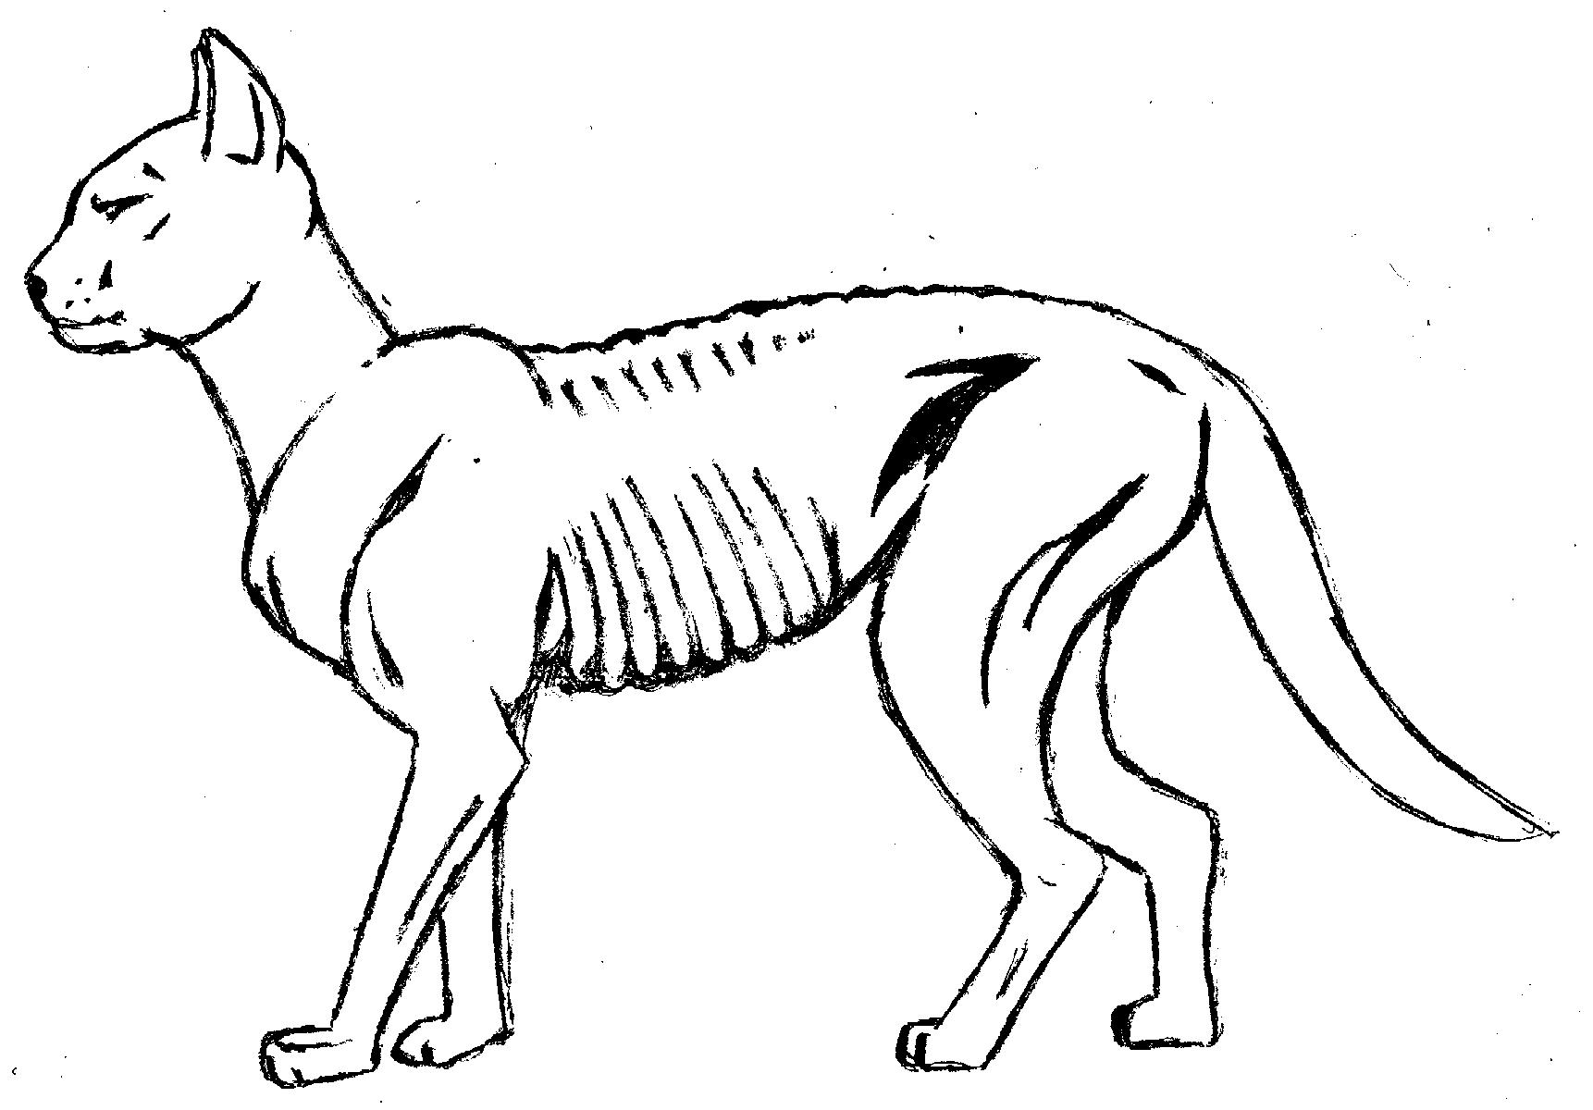  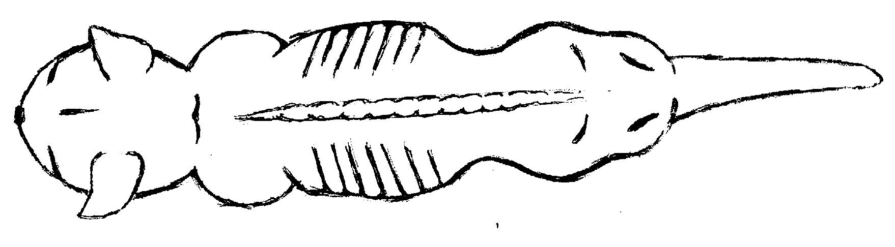 | EMACIATED  - Individual ribs, spine and pelvis prominent and evident from a distance.  - Lack of muscle mass  - Little or no body fat  - Rump hollow  - Waist prominent when viewed from above  - Neck thin  - No flank fold (under belly), abdomen very tucked up.  Veterinary advice must be sought.
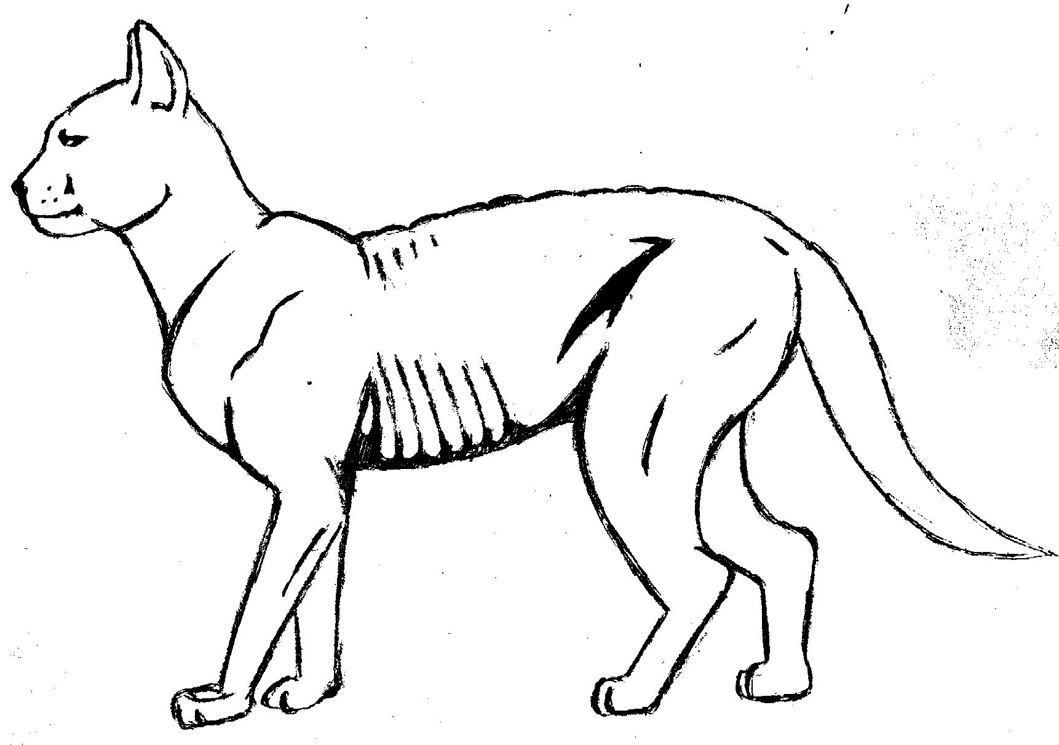  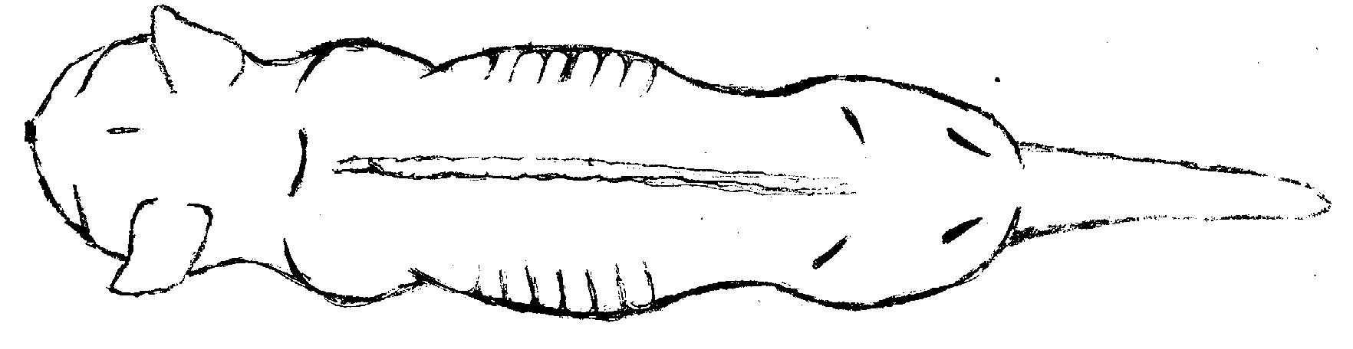 | THIN  - Ribs, spine and pelvis bones visible and easily felt  - Little body fat.  - Neck thin  - No flank fold (under belly), abdomen tucked up.  - Obvious waist when viewed from above  Increase feeding and worm cat if not wormed recently (ensure all-wormer used – some products do not cover all worms).  Seek veterinary advice if cat remains underweight or unsure of feeding or worming regime.
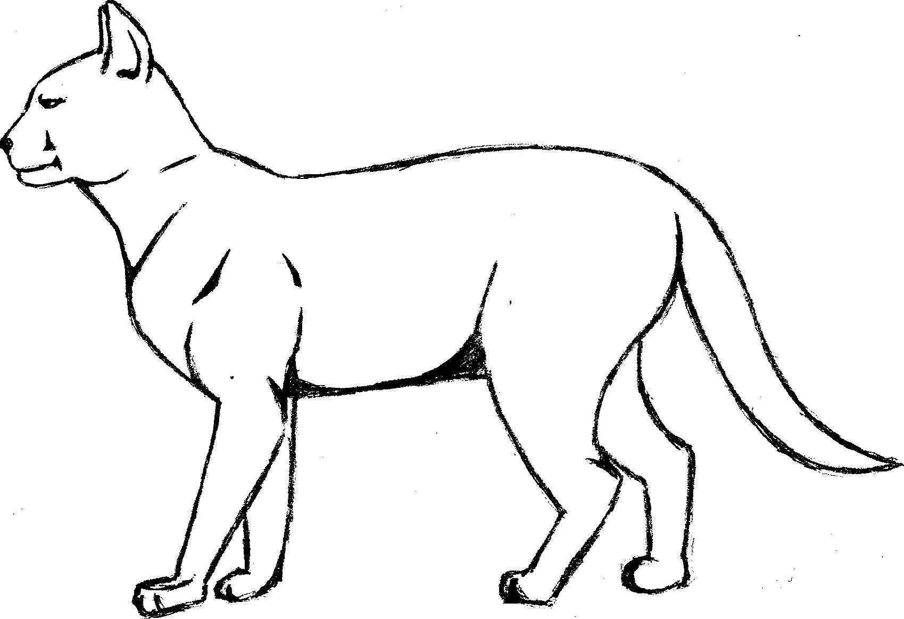  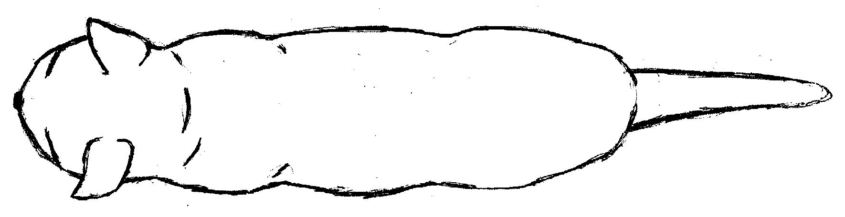 | IDEAL  - Ribs and spine can be felt, last few ribs may be visible.  - Flank fold (under belly) maybe visible from side.  - Cat should have a waist when viewed from top  - Good muscle mass
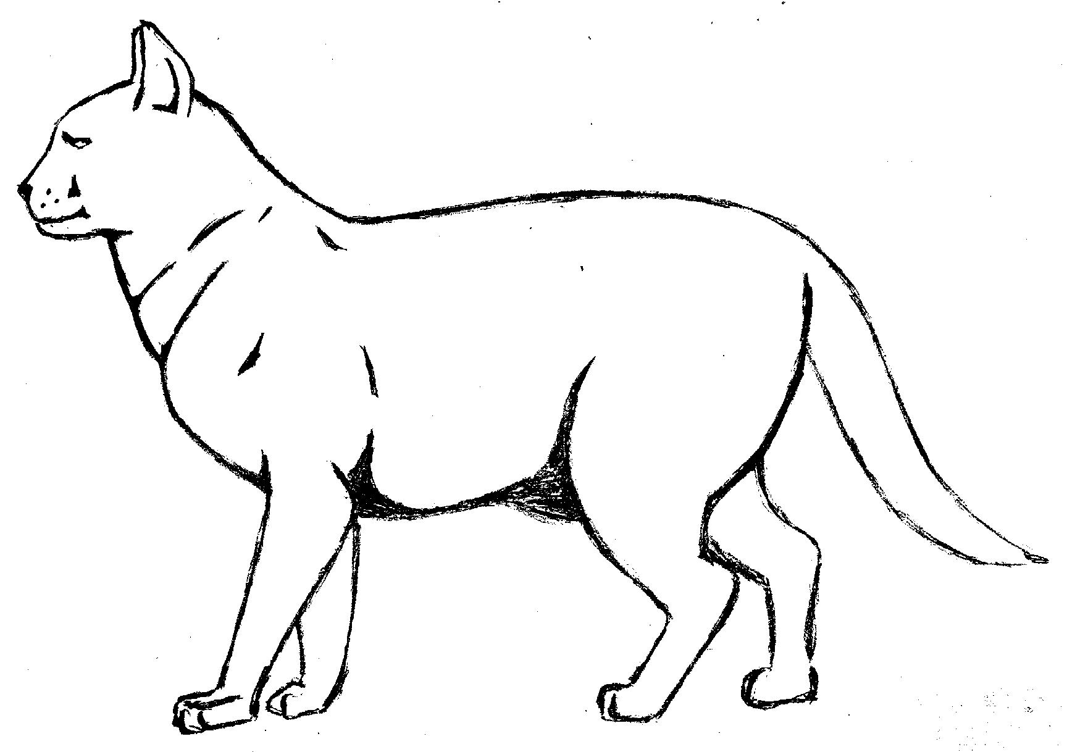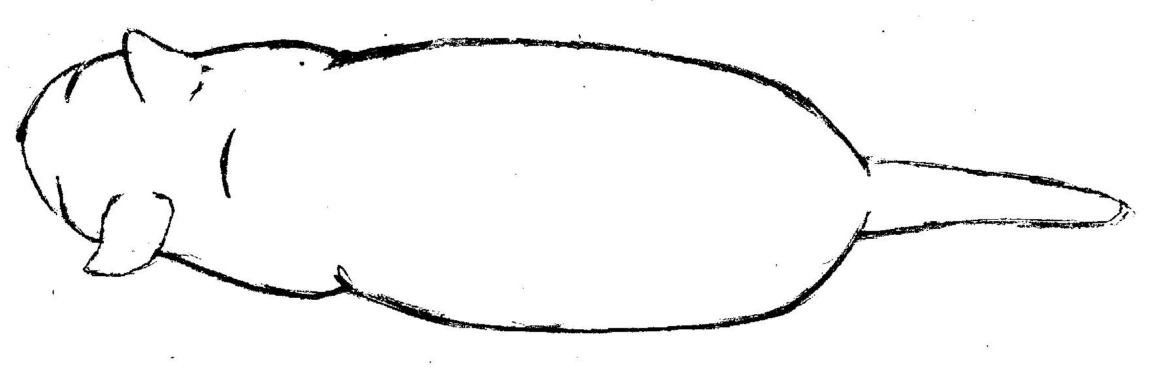 | OVERWEIGHT  - Ribs and spine not visible but can be felt.  - Little or no waist when viewed from above rounded appearance.  - Flank fold (under belly) clearly visible and will wobble when cat moves. Belly and chest rounded.  - Large ventral fat pad covering hind legs  Reduce feed intake or provide lower calorie feed. Consider options to increase exercise level of cat.
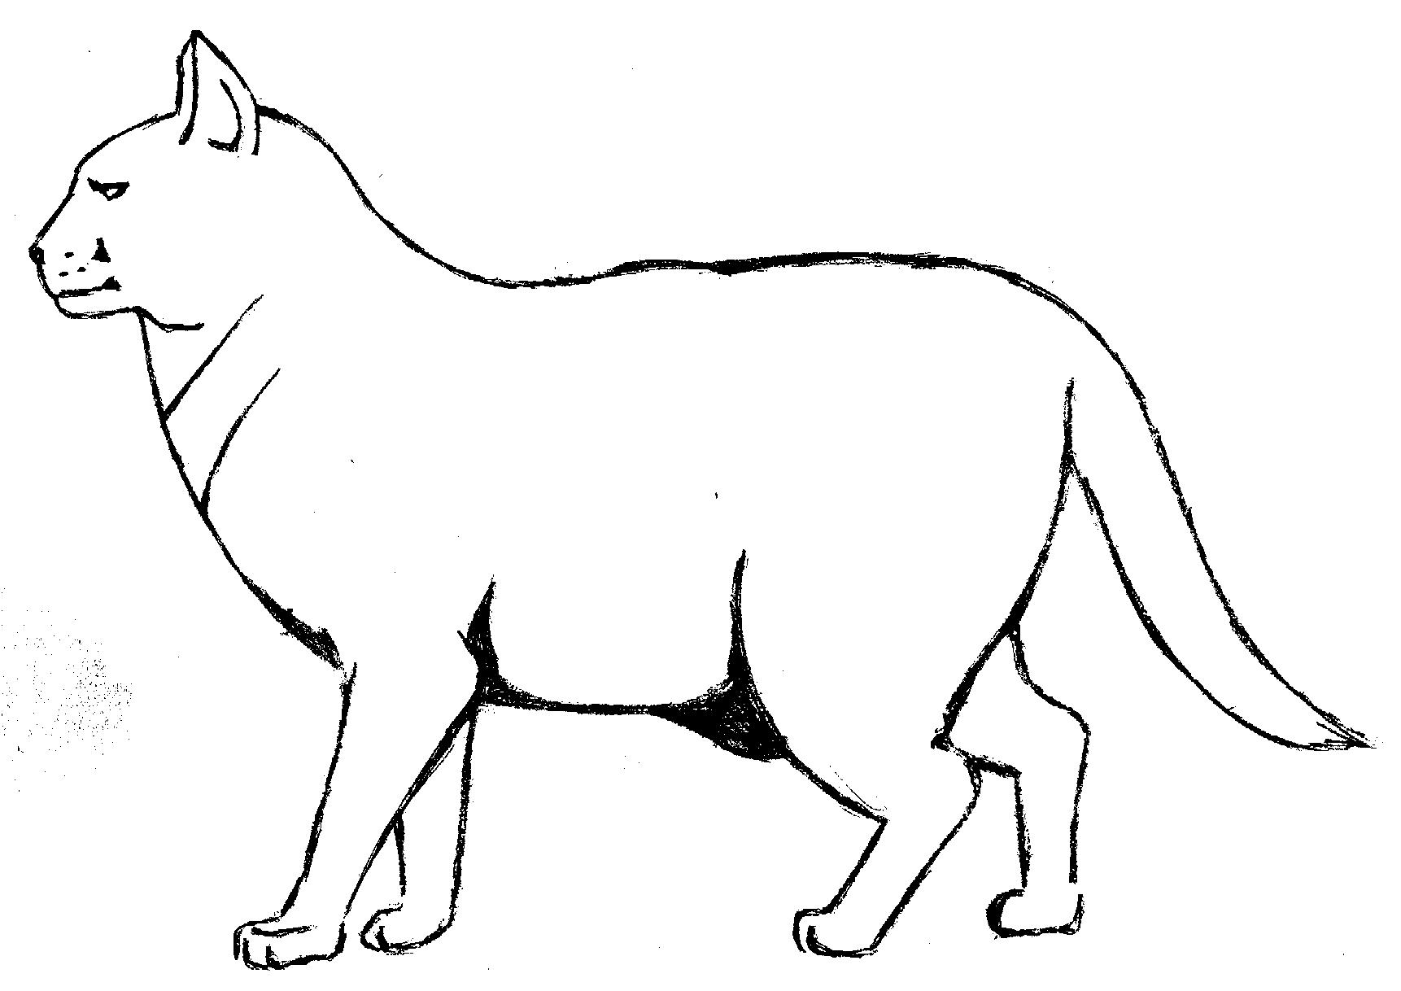  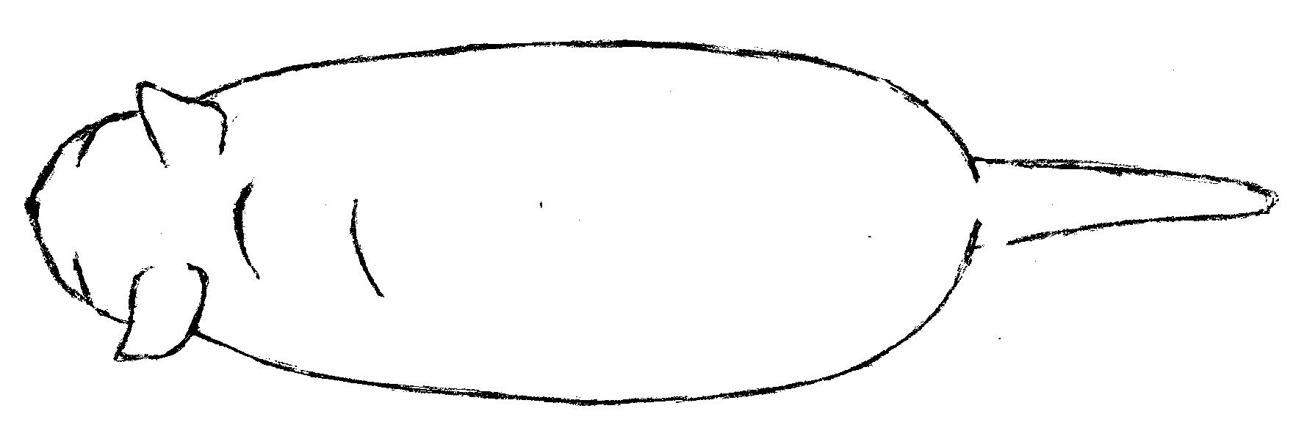 | OBESE  - Ribs and spine not visible and difficult to feel.  - Tail has obvious fat deposit  - No waist and back broadened when viewed from above.  - Flank fold (under belly) hangs down and will sway when cat moves, belly and chest very rounded.  Seek veterinary advice on diet and exercise regime.

Body Condition Chart - Dogs

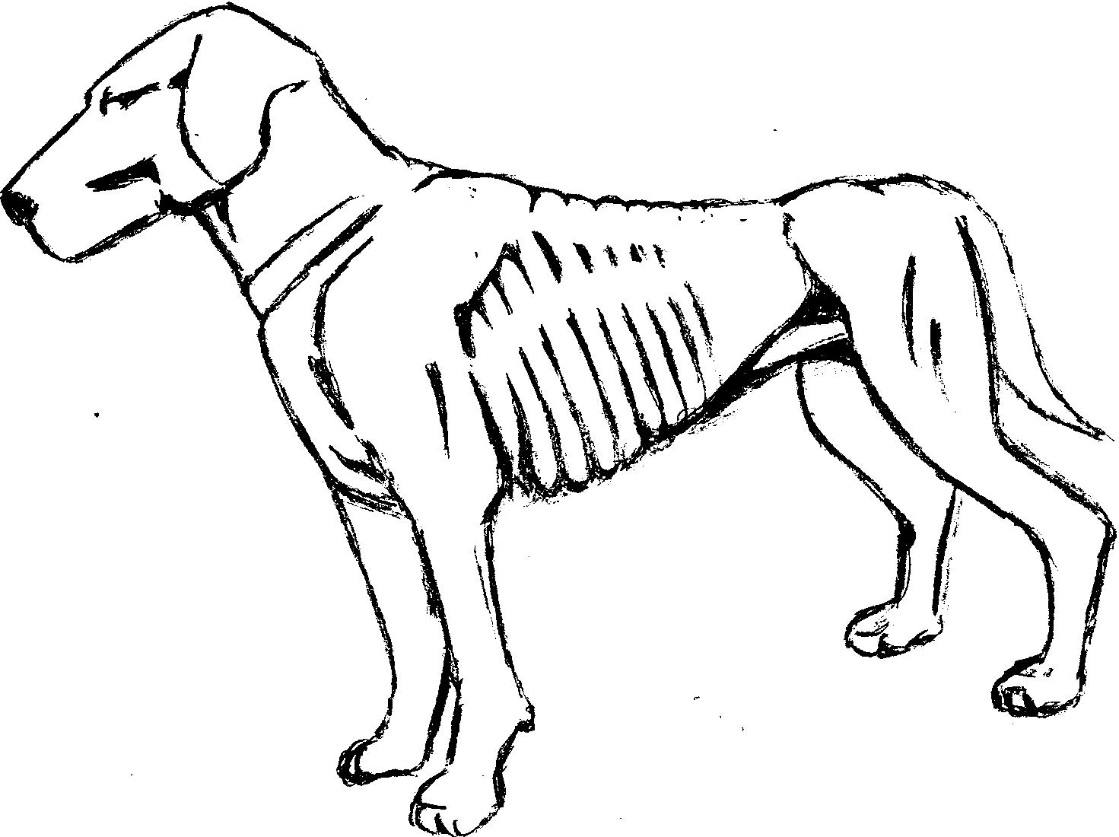  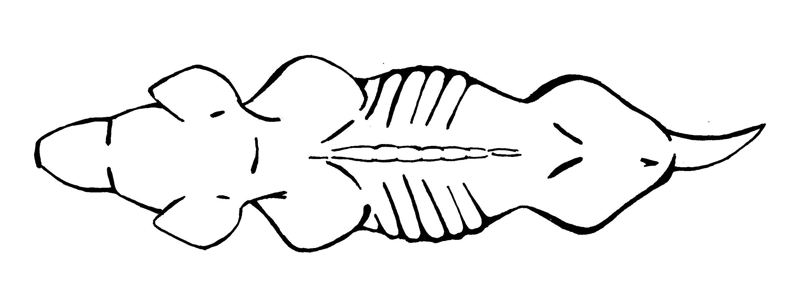 | EMACIATED  - Individual ribs, spine and pelvis prominent and evident from a distance  - Lack of muscle mass  - Little or no body fat  - Rump hollow  - Waist prominent when viewed from above  - Abdomen obviously tucked up  - Neck thin  - No fat on tail  Veterinary advice must be sought.
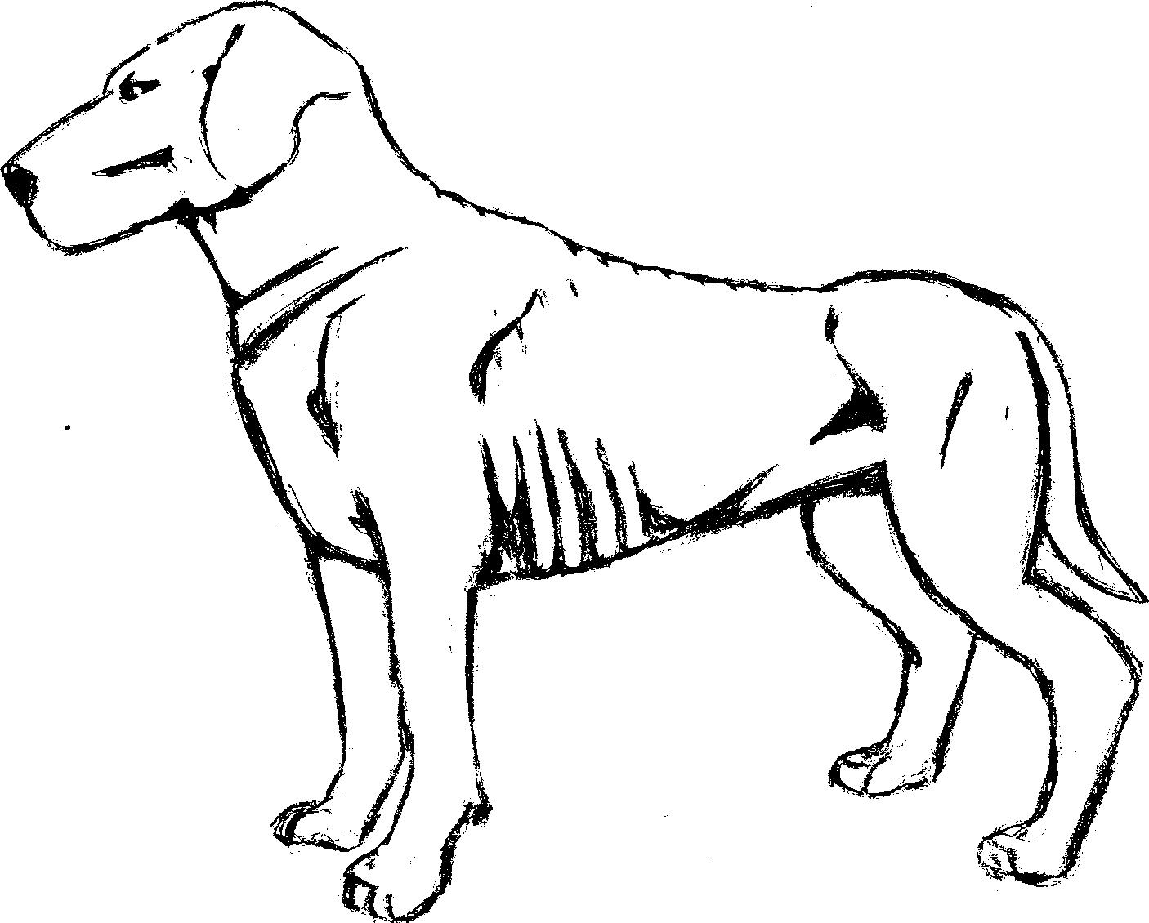  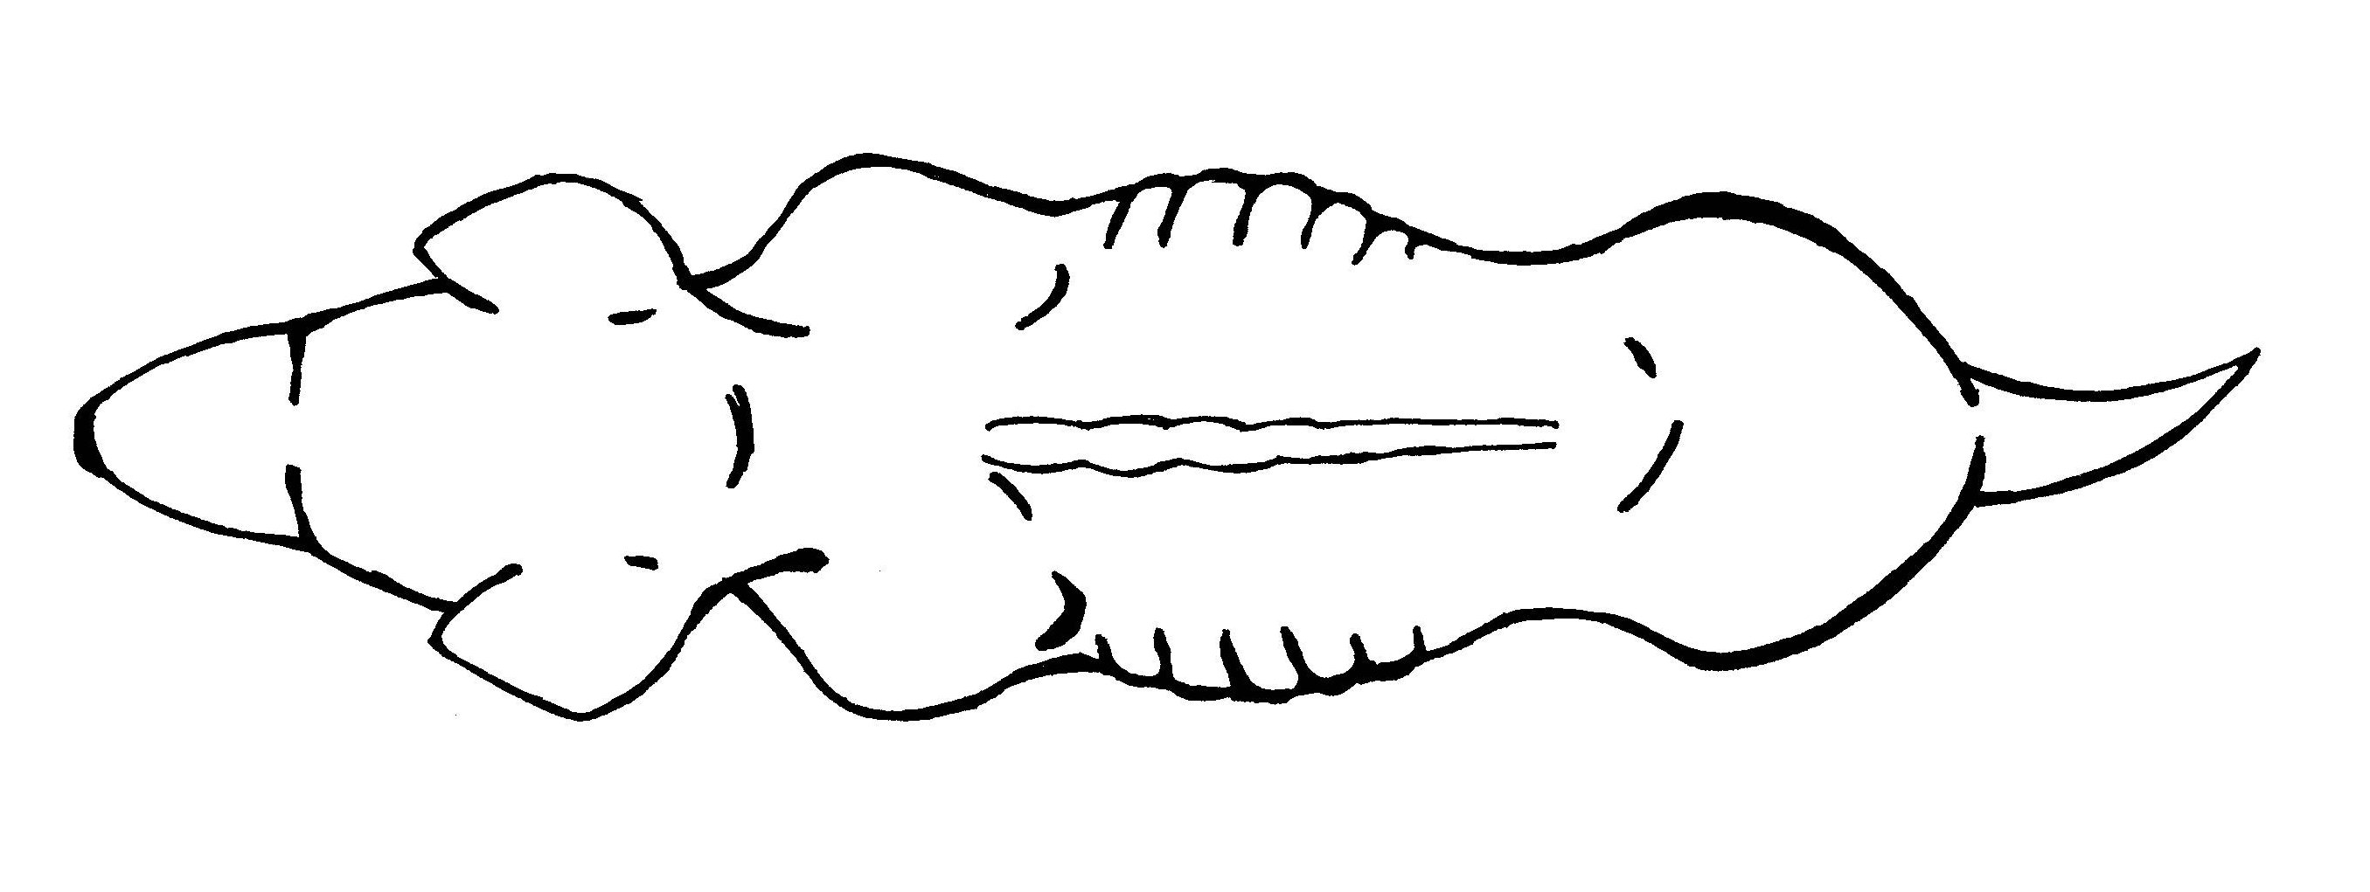 | THIN  - Ribs, spine and pelvis bones visible and easily felt  - Little body fat  - Neck thin  - Abdomen tucked up  - Little fat on tail  - Obvious waist when viewed from above  Increase feeding and worm dog if not wormed recently (ensure all-wormer used – some products do not cover all worms).  Seek veterinary advice if dog remains underweight or unsure of feeding or worming regime.
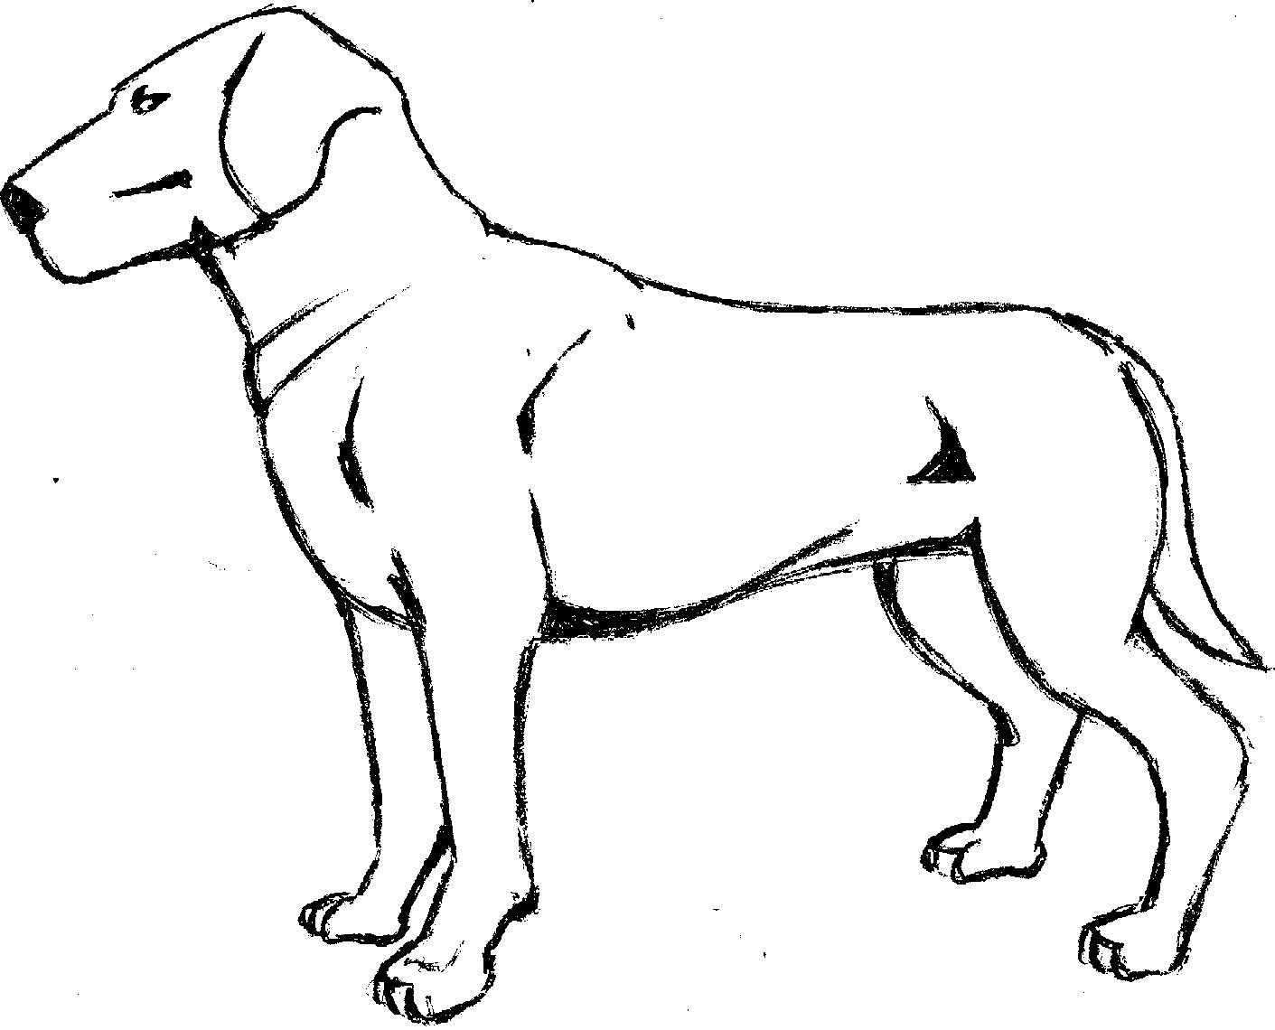  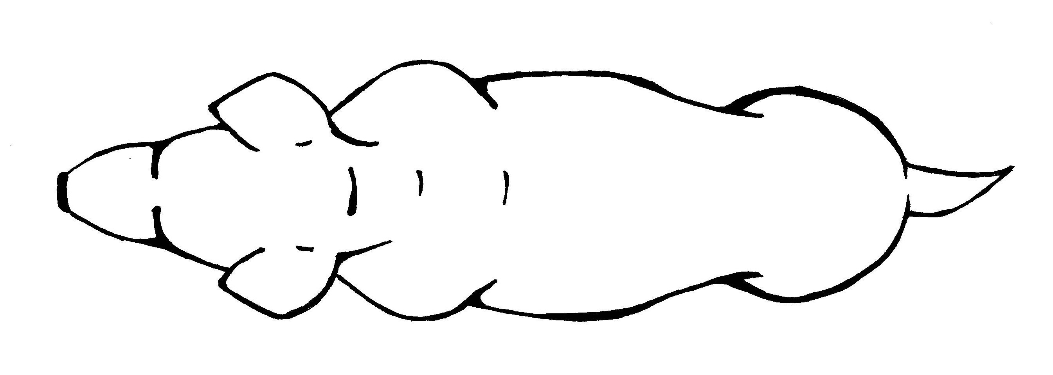 | IDEAL  - Ribs and spine can be felt, last few ribs may be visible  - Dog should have a waist when viewed from above  - Belly is tucked up when viewed from side  - Good muscle mass  - Rump well muscled
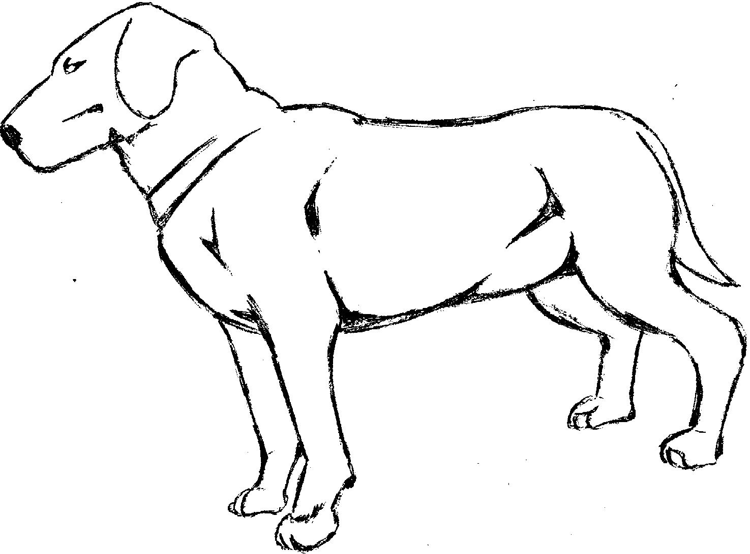  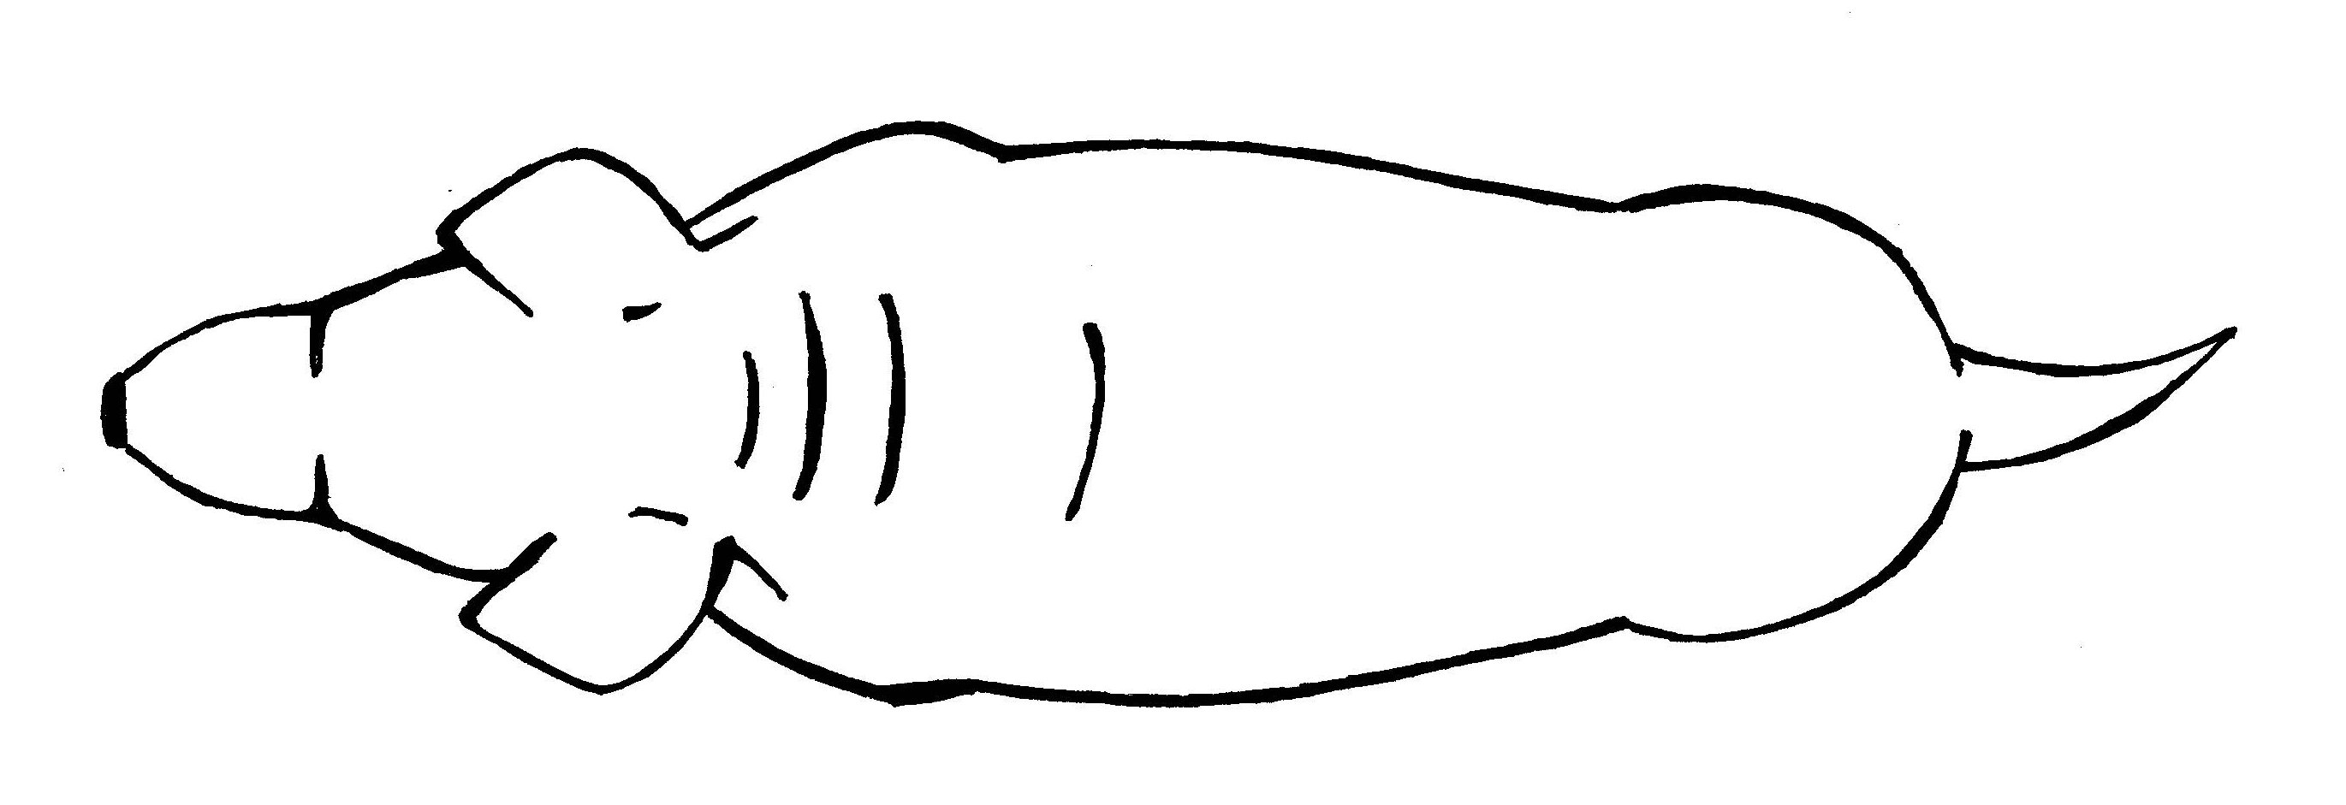 | OVERWEIGHT  - Ribs and spine not visible but can be felt  - Fat deposit on tail  - Little or no waist when viewed from above, rounded appearance, back appears broadened  - Dog squarish along back line when viewed from side  - Abdomen not tucked up, may appear rounded underneath  Reduce feed intake or provide lower calorie feed. Increase exercise.  Seek veterinary advice if unsure of appropriate diet or concerns over exercise regime.
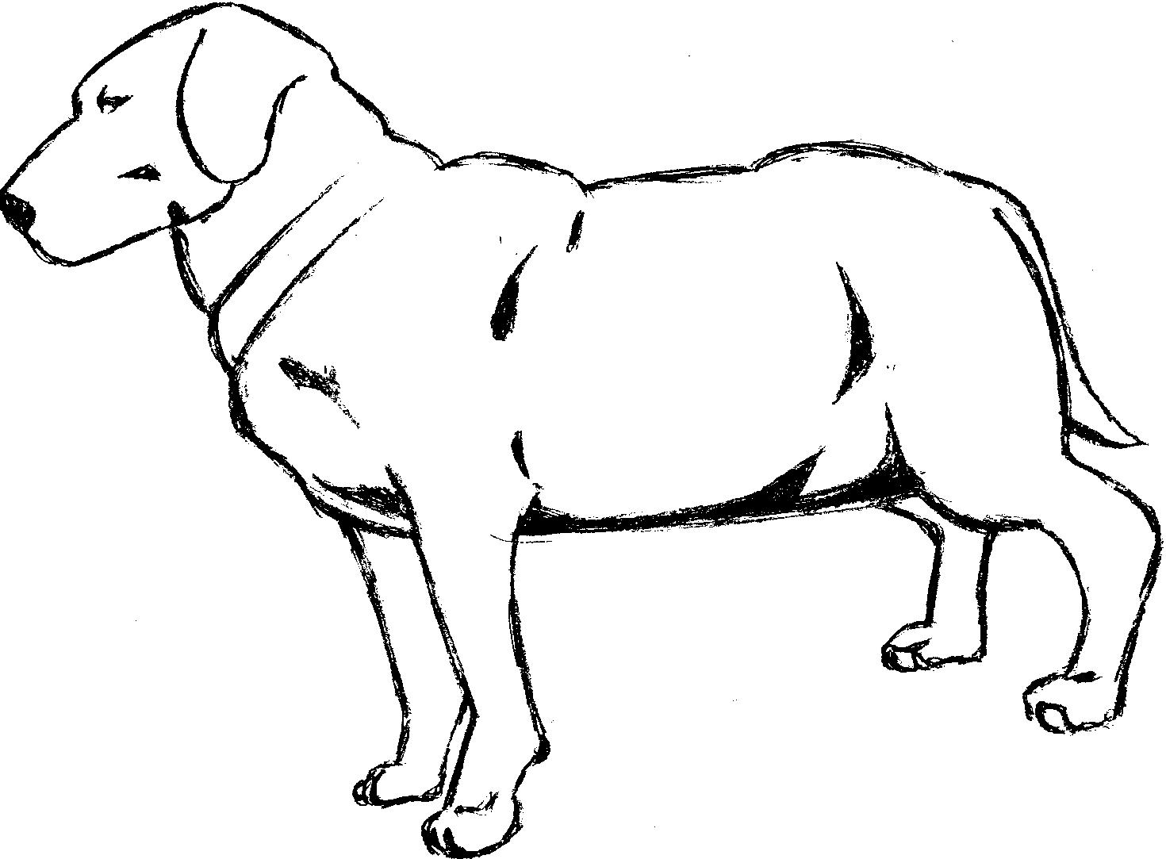  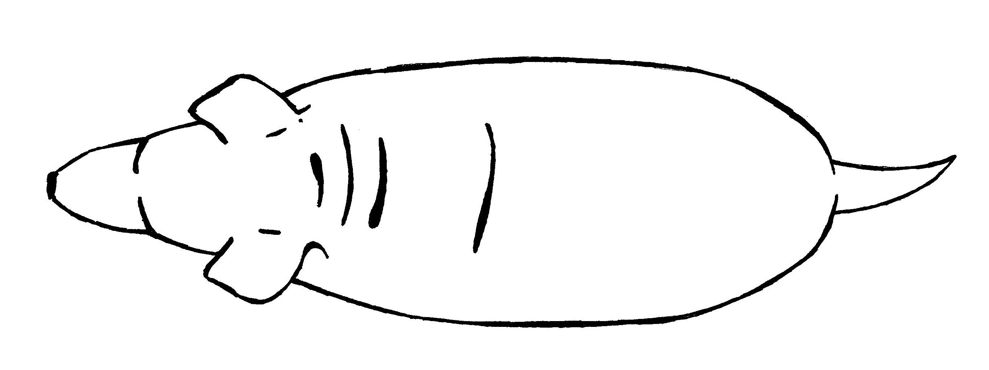 | OBESE  - Ribs and spine not visible and difficult to feel  - Tail has obvious fat deposit  - No waist and back broadened when viewed from above  - Belly obviously rounded and possibly distended  - Dog square or rounded up along back line when viewed from side  Seek veterinary advice on diet and exercise regime.

